**ENCAPSULATION**

Erwan Majid/08/2i

Link github:

3.1 Experiment 1 – Encapsulation

Class Motor:

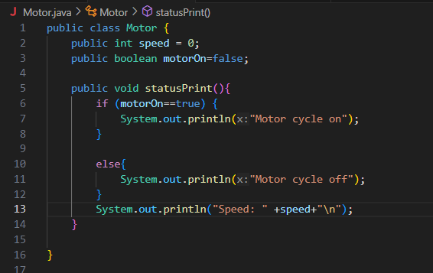

Class Motordemo:

